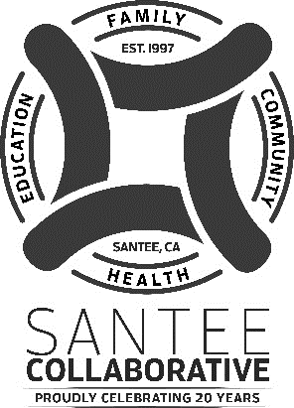

The Mission of the Santee Collaborative is to
promote a healthier, proactive community
that builds resilient children and families.

Santee Collaborative Coordinating Council Meeting Notice
DATE: July 7, 2021
TIME: 3:00 - 4:30 p.m.
PLACE: District Conference Room
The business to transact at the meeting shall be limited to the following:
1. Welcome – Ken Fox 10
- Approval of Agenda
- Approval of Minutes for June 2, 2021
- Public Communication
- Planning for Santee Summer Concerts
  - Should we have a table? 15
- Survey Information
  - Field Trips/ Speakers 15
- Collaborative Planning 15
- Upcoming Meeting: August 25, 2021
- Next Coordinating Council Meeting
- Director’s Report 10
- Announcements/Resources/Concerns 10
- Adjourn Next Meeting TBA

